

Local Faculty
Singapore Thoracic Society

Lee Pyng (Course Director)
Associate Professor, Senior Consultant
RCCM, National University Hospital

Khoo Kay Leong
Senior Consultant
RCCM National University Hospital

Felicia Teoh
Consultant
RCCM, National University Hospital

Regional Faculty
Malaysian Thoracic Society

Tengku Saifudin
Associate Professor
Universiti Teknologi Mara (UiTM)

Ahmad Izuanuddin Ismail
Universiti Teknologi Mara (UiTM)

International Faculty

Henri Colt
Professor of Medicine USA
Bronchoscopy International

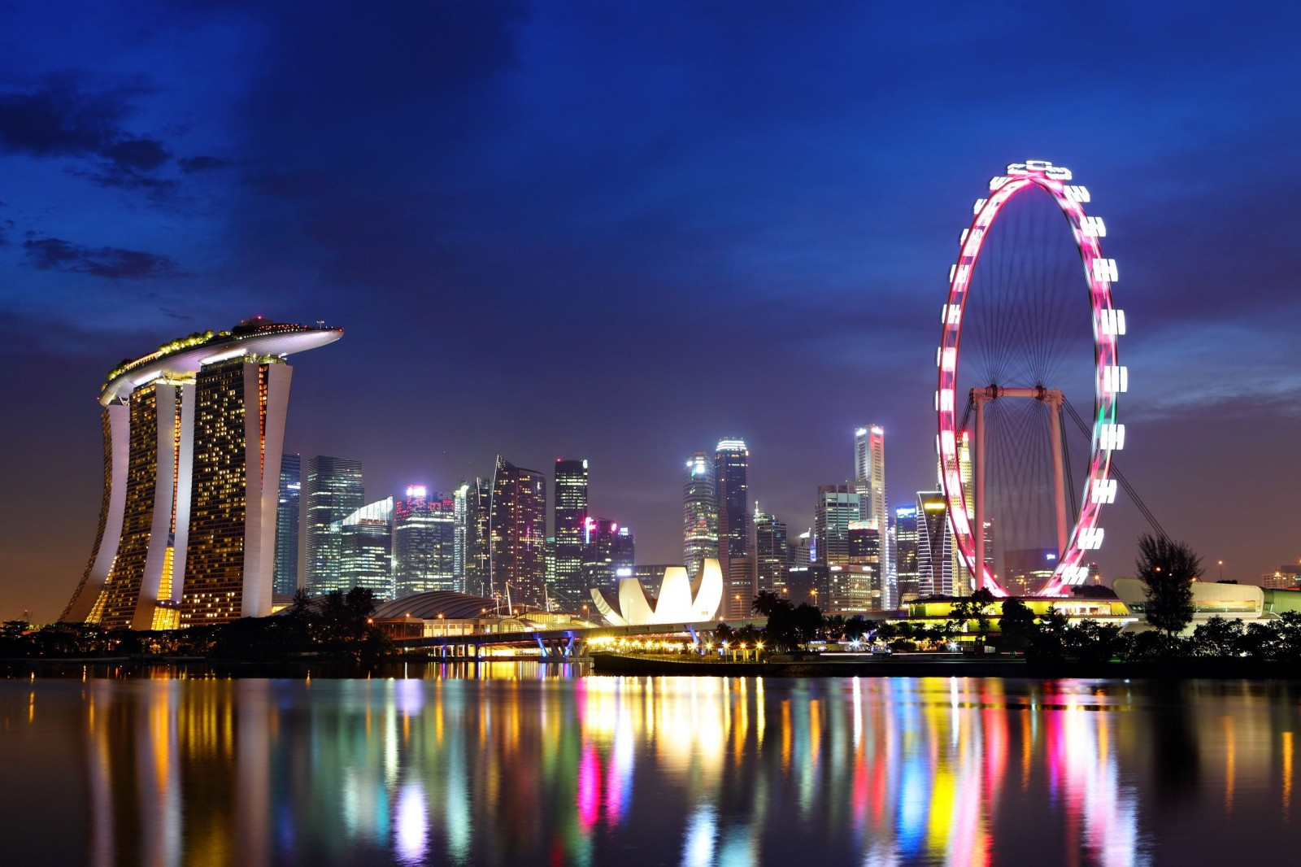

Target Audience: Pulmonary Medicine, Critical Care Medicine, Cardiothoracic and Anesthesia trainees, interested in acquiring significant exposure to basic bronchoscopy skills.
Course Objectives:
Acquiring cognitive and experiential knowledge as well as technical skills in performing flexible bronchoscopy in a structured training program based on the Bronchoscopy Education Project 2013. This course utilizes both didactic lectures and well as low and high fidelity simulators to enhance learning of participants. By the end of the introductory course, participants would have achieved the following objectives:
- Increased factual knowledge of flexible bronchoscopy as it pertains to patient safety, prevention and response to complications, and bronchoscopy in special populations
- Enhanced medical decision-making ability and prebronchoscopy evaluation
- A working knowledge of airway anatomy, brushing, biopsy, TBLB and TBNA
- Improved technical skills in performing bronchoscopic inspection, BAL, Brusing, Biopsy, TBNA and emergency bronchoscopic intubation
INTRODUCTION TO FLEXIBLE BRONCHOSCOPY AND TRAIN THE TRAINERS 20 April 2014
NUHS, SINGAPORE

Full Name______________________________________________
Mailing Address _________________________________________
Phone ( ) _______________ Fax ( )____________________
Email address____________________________________________ Profession_______________________________________________
Organization Affiliation ____________________________________

Registration Fee:
SGD $500 Introductory Bronchoscopy Course and Train the Trainers
SGD $300 STS / MTS Members for Introductory Bronchscopy Course Only
SGD $150 Allied Health
Form of payment:
Visa
Mastercard
Credit card number ______- ______-_____-_____
Expiry date ________/_______
Grand Total: S$________
Name as it appears on card ______________________

Signature ____________________
Contact us: Tel: (65) 67726533, Fax: (65)68724101, Email:pynglee16@gmail.com

Course Registration

NUHS Tower Block Level 1, 1E Kent Ridge Road

20 April 2014 Registration 8:00 am – 8:15 am

0815-0820 Introduction by Course Director

0820-0850 Pre-test Assessment

0850-0920 Prebronchoscopy evaluation: 4-box practical approach

0920-0950 Bronchoscopic inspection and airway anatomy

0950-1000 Tea Break

1000-1030 Basic diagnostic procedures: BAL/Brushing/Biopsy

  - Transbronchial lung biopsy and TBNA

  - Management of complications

1130-1200 Bronchoscopy in special populations

1200-1300 LUNCH

1300-1500 Hands on Workshop: 30 mins per station

Stations (1-3) Bronchoscopy step by step (Trainees)
Station (4) Practical Approach

Train the Trainers with Professor Henri Colt (2 hours)
1500-1530 Tea Break

Station 5 Emergency Bronchoscopic intubation

Station 6 TBNA

Station 7 Bronchoscopy step by step Assessment Tools (Trainers)

1630- 1730 Post-test Assessment, Certificates

